LIFE PROCESSES
1. What is the stored form of carbohydrates in plants and animals respectively?
2. Which digestive secretion does not contain any enzyme but is important? Discuss.
3. Write the sequence of steps in photosynthesis? How is it different in desert plants and those in temperate regions?
4. Identify structure 1-4 in the given figure:
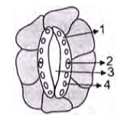
5. What is the role of cartilaginous rings on trachea?
6. Why is respiration considered an exothermic process?
7. Name the respiratory pigment in human beings? What is its role?
8. What is residual volume in our lungs? What is its importance?
9. Why rate of breathing in acquatic animals has to be faster than that in terrestrial animals?
10. Give schematic representation of different pathways of breakdown of glucose molecule.

11. What is the role of valves in veins?
12. Why are arteries thick walled and elastic?
13. Why are ventricles thick walled and muscular?
14. Describe double circulation in human beings. Name the group of animal with double circulation? How is it important for them?
15. What are the strategies of plants to get rid of their wastes?
16. What is the composition of urine? Are glucose and proteins normally present in urine? Why? How is volume of urine regulated?
17. Describe the structure and function of nephron.
18. What are the possible observations in the given setup?

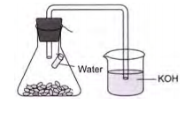
19. Why is small intestine in herbivores longer than in carnivores?
20. What will happen if mucus is not secreted by the gastric glands?

